Joy to the world; Toastmasters is having a Christmas Party!!
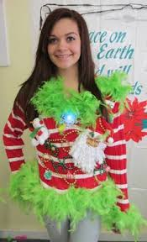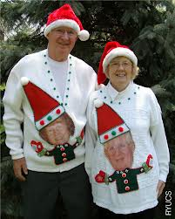

Come join the events this year!!
Starting with our Ugly Christmas Sweater Contest!!
With 1st, 2nd and 3rd prizes!!
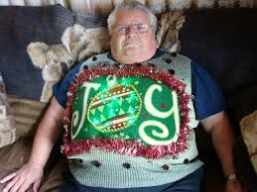
All are welcome to join in the Christmas exchange,
Just bring a unisex gift valued at $20.00 and join in with the fun!!
A beautiful 3 Course Christmas Dinner awaits you, friends and family for a small cost of $25.00. Any alcohol (Wine, Beer, Highballs, etc…) can be purchase separately at the bar for $6.00…

Please help us with numbers of who are coming for the evening ____
Are interested in the Christmas exchange Yes ___ No ____
Please email Donna Lee Albertson at dalbertson@westjet.com before Thursday, December 11th so we can submit the final numbers to the Elks Club.

